Climate Change Impact and Implication on Sugarcane and Mitigation Strategies in Pakistan.

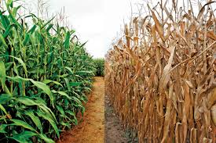

By
Sahibzad Khan(Director)
Regional Meterological Centre Lahore

Table of contents
Sugar-cane and climate……………………………………………………………………………………1
Temperature……………………………………………………………………………………………………1
Annual Temperature Trends 1901-2014………………………………………………………….2
Rainfall……………………………………………………………………………………………………………..2
Annual Precipitation Trends 1901-2014……………………………………………………………..3
Sugarcane Impact on Local Climate…………………………………………………………………….4
Future rainfall projections of Pakistan……………………………………………………………….8
Mitigating Impact of Stress Environment and Sustaining Sugarcane Production…10
Environmental Losses…………………………………………………………………………………………10
Conclusion………………………………………………………………………………………………………….11
Recommendation………………………………………………………………………………………………11
Summary and Future Perspectives…………………………………………………………………….12

Climate Change Impact and Implication on Sugarcane and Mitigation Strategies in Pakistan

Sugar-cane and climate:-
- Pakistan is basically a developing country of high unevenness and deficient rainfall. Lying at extreme north- west corner of the indo-pak sub-continent.
- At this time developing countries are facing lack of food and water which is a direct impact of high temperature.
- Consistently increasing high temperature is increasing problems in the domain of agriculture and irrigation.
- The high temperature of climate is a risk factor against crop production and thus can lead to storage of food.
- The climate of Pakistan leads to significant inter annual variability in the frequency of many extreme weather types, such as sub-tropical cyclones and associated storm surge, floods and droughts.Sugar- cane is mostly irrigated and partially rain-fed, climate variability has a major impact not only on sugar production but also on the national economy. Therefore, it is essential to understand the impact of major changes in climate patterns that affect sugar-cane and sugar yield.
Temperature:-
The rate of photosynthesis is dependent on temperature, as are many other biochemical processes controlling meristematic activity for leaf and bud development. Photosynthesis efficiency of sugar-cane increases in a linear manner with temperatures in the range of 8°C to a maximum of 34°C. Cool nights and early morning temperatures 14°C in winter and 20°C in summer significantly inhibit photosynthesis. The stalk elongation of sugar-cane is also sensitive to temperature, with general acceptance that the peak growth phase is terminated by onset of mean day temperatures less than 21°C.

- Annual Temperature Trends 1901-2014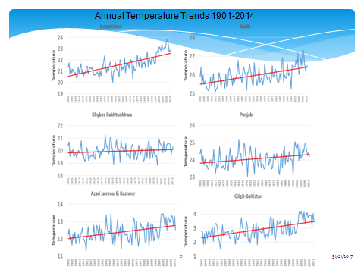
Rainfall:-
Rainfall is the single most important factor responsible for sugar-cane production in the rainfed sugar industry of Pakistan. As rainfall is significantly affected by extreme events. The annual rainfall averages between 400 mm and 700 mm, of which 90 per cent falls in summer monsoon between July and August in sugarcane growing locations. The winter rainfall comes from Mediterranean rains in winter less than 10 percent this low rainfall has a major effect on crop production.

Annual Precipitation Trends 1901-2014:-

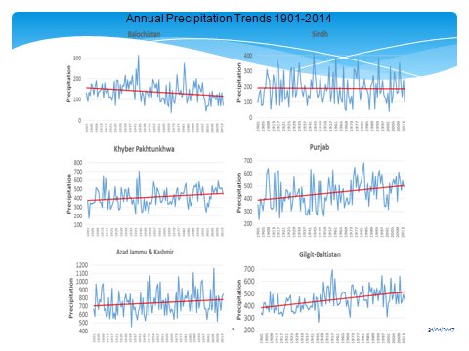

Sugarcane Impact on Local Climate:-
In a region, changes in farming systems and crop combinations may directly or indirectly affect local climate factors. Residue burning before or after sugarcane harvest is a common management practice of sugarcane production in many countries. Greenhouse gas emission in sugarcane production is the major concern. A recent research indicated that approximate 2.4 tons of CO2 equivalent ha−1 was released to the atmosphere by sugarcane crop. The major contributors of the released CO2 from sugarcane were residue burning (44%), the utilization of synthetic fertilizers (20%), and fossil fuel combustion (18%) . Therefore, improving green harvest can increase soil organic carbon and reduce CO2 emission from sugarcane production.

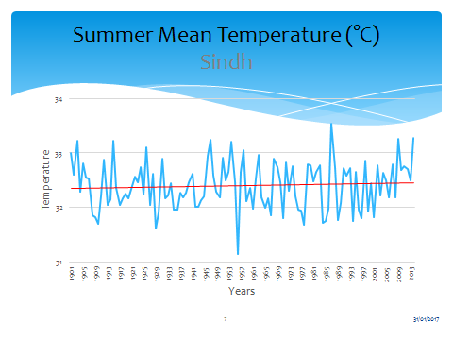
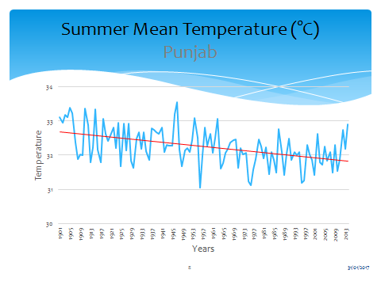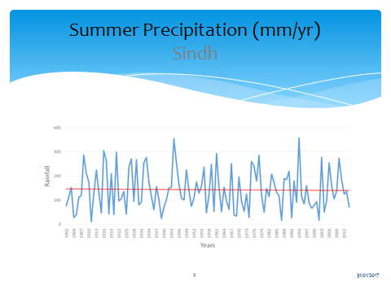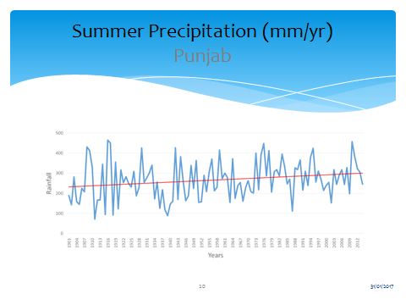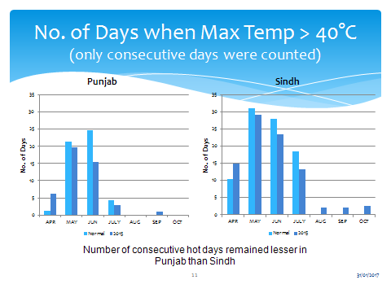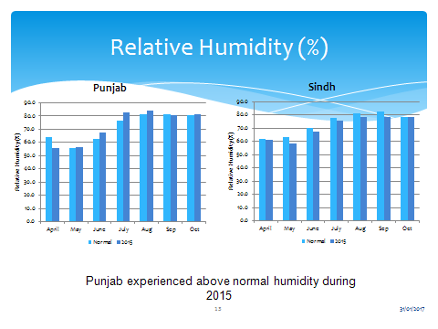
Future rainfall projections of Pakistan:-
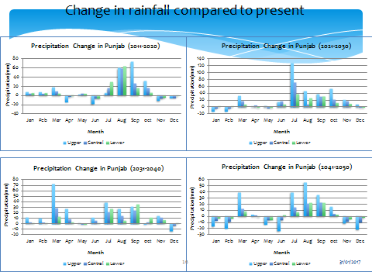
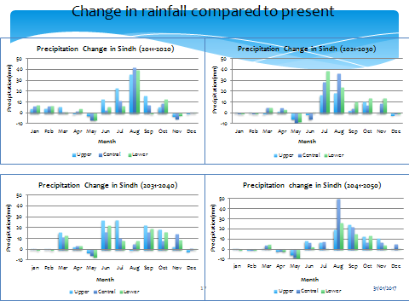

Mitigating Impact of Stress Environment and Sustaining Sugarcane Production:-
Some mitigation and adaptation strategies for climate change in sugarcane production these mitigation strategies included planting drought tolerant varieties, investing irrigation infrastructure, improving irrigation efficiency and drainage systems, and improving cultural and management practices. that adaptation strategies should focus special attention on technologies and management regimes that will enhance sugarcane tolerance to warmer temperatures during winter and especially the harvesting phases. Thus, development of the stress tolerant and high-yielding sugarcane cultivars is one of the important strategies in adaptation of climate change.
Environmental Losses:-
- Increased amount of fertilizers but deeper than root zone.
- Spray wash-away due to frequent wet spells.
- Polluting water and soil environment.

Conclusions:-
Climate Change affects all levels of sugar industry, from cane cultivation to harvesting, transport, milling, marketing and shipping. Accurate weather forecasts to develop strategies at grower level with strong scientific knowledge of the agro-climatic calendar. Climate is an important resource for agricultural countries such as Pakistan, where the contribution to global greenhouse emission is very high but where the future effects of climate change are expected to be significant. These impacts will be felt by many future generations because the country have low adaptive capacity, high vulnerability to natural hazards and mitigating strategies. Significant challenges would result from increases in the frequency and intensity of extreme climate events, such as floods, drought sand tropical cyclones.

Recommendations:-

- Developing new farming systems
- Developing alternative foods
- Enhance information on agricultural research
- Encouragement of information exchange among farmers
- Promote the development of agricultural weather information systems including the use of long-term weather forecasts.

Summary and Future Perspectives:-

Clearly, sugarcane production has been and will continue to be directly or indirectly affected by changes in climate conditions. The most significant challenges for sugarcane production are increases in frequency and intensity of extreme weather events, especially drought during climate change. Existing adaptation strategies can help offset many but not all effects in the future. The negative effects of climate change on sugarcane production are very likely to worsen after 2050, especially if greenhouse gas emissions still remain high. Therefore, agricultural scientists and decision makers need to work closely to mitigate the potential negative effects of climate change on agriculture and to improve sugarcane yields by multidisciplinary approaches, such as consistently developing new sugarcane cultivars using breeding and molecular biology, refining best management practices, improving new technology transfer, and increasing productivity and profitability. Improving the resilience of sugarcane production systems to climate change requires protection of the natural resource (especially water and soil) for sustainability. Expanding use of sugarcane products for sugar, ethanol, cellulosic biofuel, and other coproducts can further improve profits.

